COAL LAB 1 TASKS
Task 1:
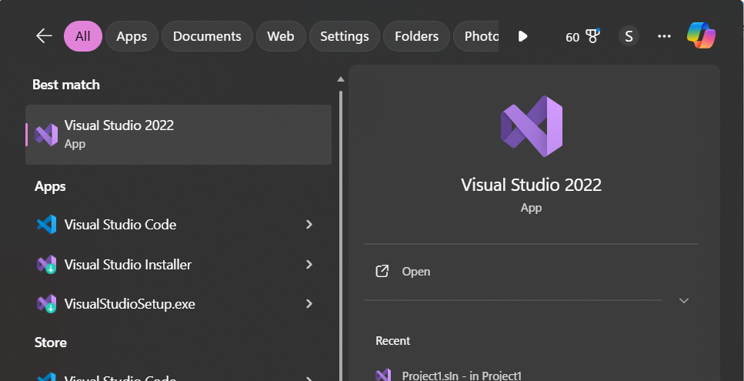
include Irvine32.inc

.data

.code
main PROC
mov eax, 10
mov ebx, 6
add eax, ebx
mov ecx, eax
mov eax, 50
mov ebx, 5
mov edx, 0
div ebx
sub eax, ecx
mov ecx, eax
mov eax, 63
mov ebx, 10
mov edx, 0
div ebx
mov eax, ecx
mul edx

call writeInt

exit
main ENDP
END main
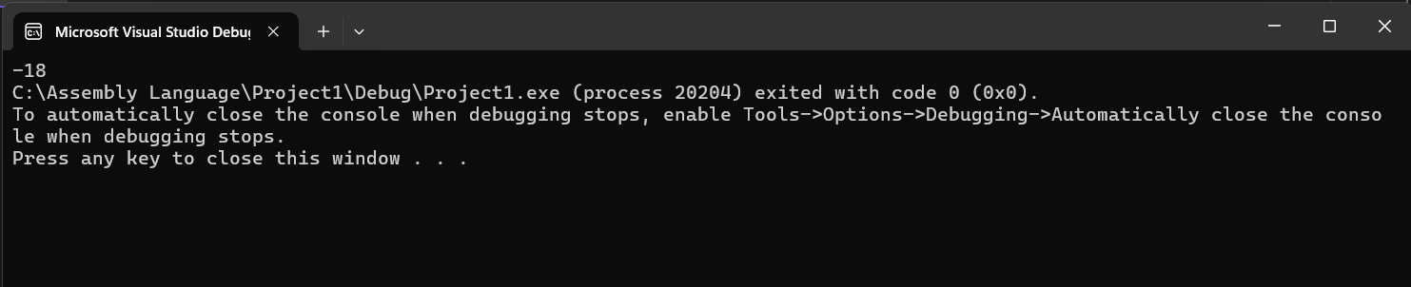
Task 2:
include Irvine32.inc

.data
msg byte "Hello World",0
.code
main PROC
mov edx, offset msg
call writeString
exit
main ENDP
END main
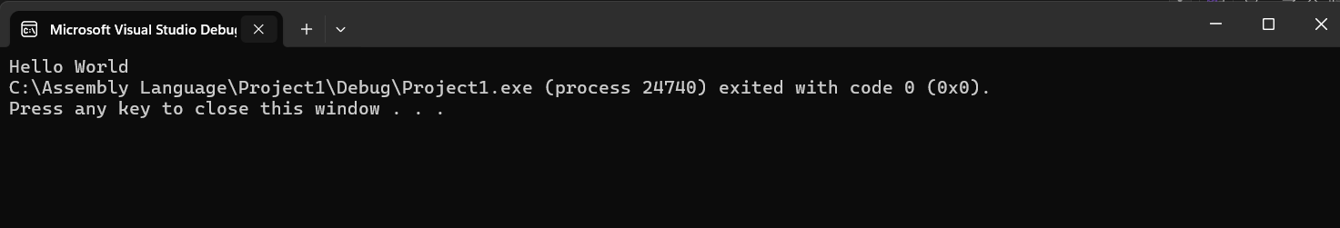
Task 3:
include Irvine32.inc

.code
main PROC
mov eax,10h
mov ebx,20h
mov ecx,30h
mov edx,40h
call dumpRegs
exit
main ENDP
END main
